# Advanced Software Engineering

## LAB1/ Assignment1

Student Details:

Sivakumar Pothala

16148142

Computer Science

# ScrumDo

1. Created a new ScrumDo account "Shivapothala"

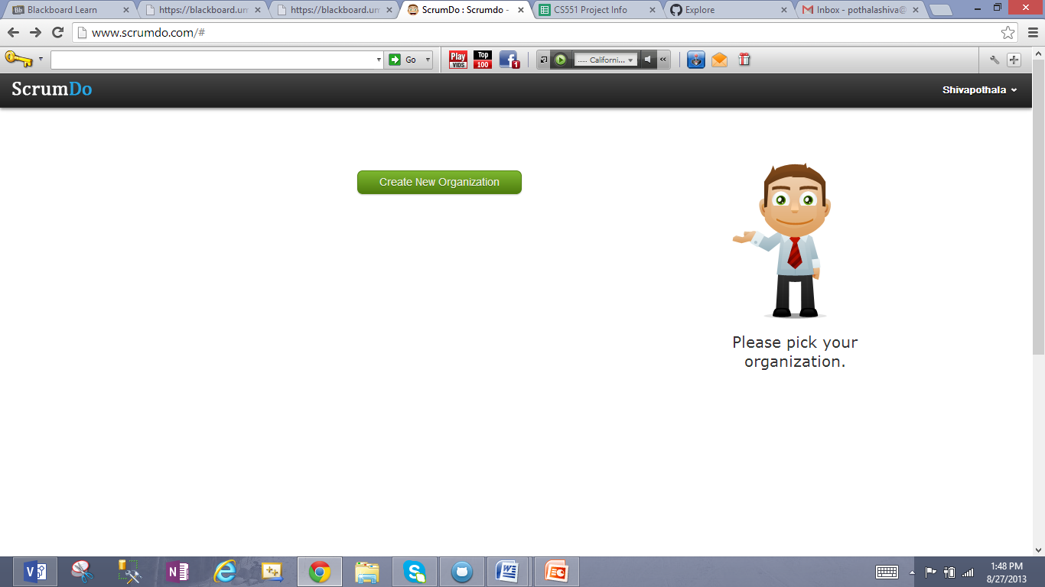

1. Creating new Organization "UMKC"

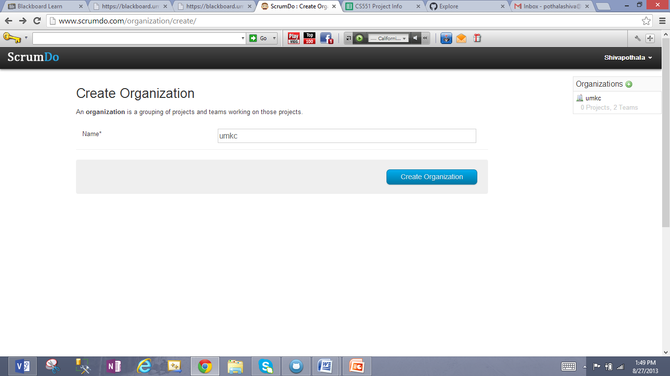

1. Creating a Project "ASE Project1" under Organization UMKC.

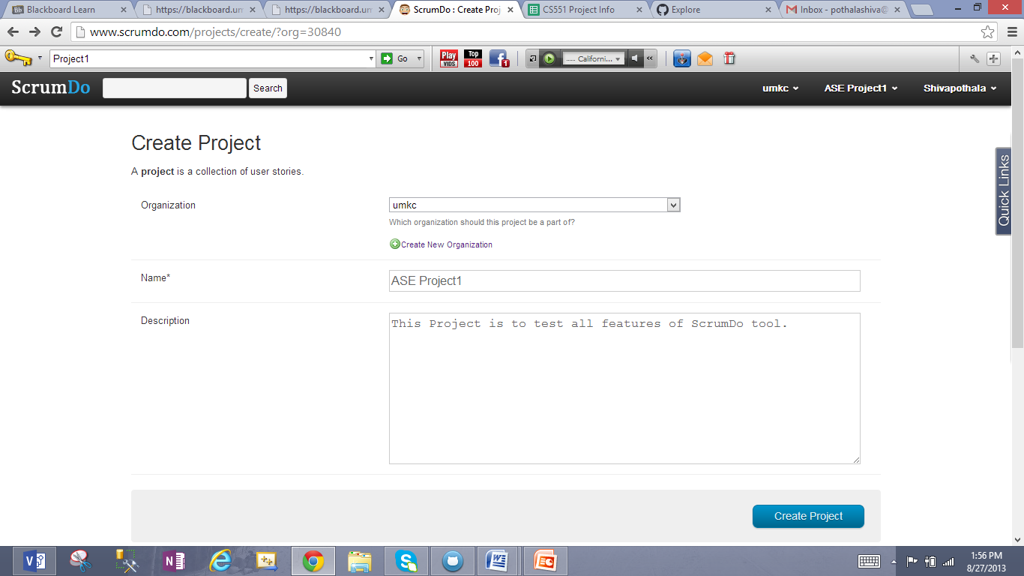

1. See Project name and Organization details in below screen.

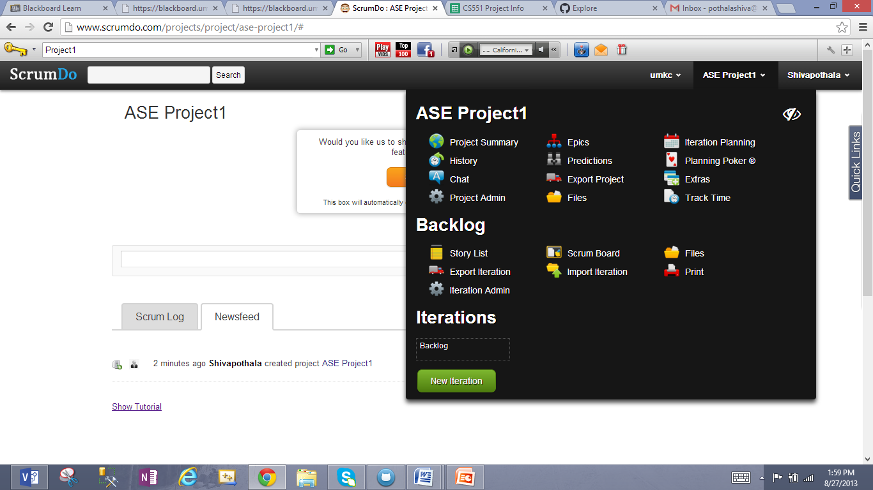

1. Creating a Story for above Project by adding below details

Summary: AS a Student, I want to test all features of this tool to do my research project.

Points: 8

Assigned to: Sivakumar

Backing Position: Bottom

Iteration: Backlog

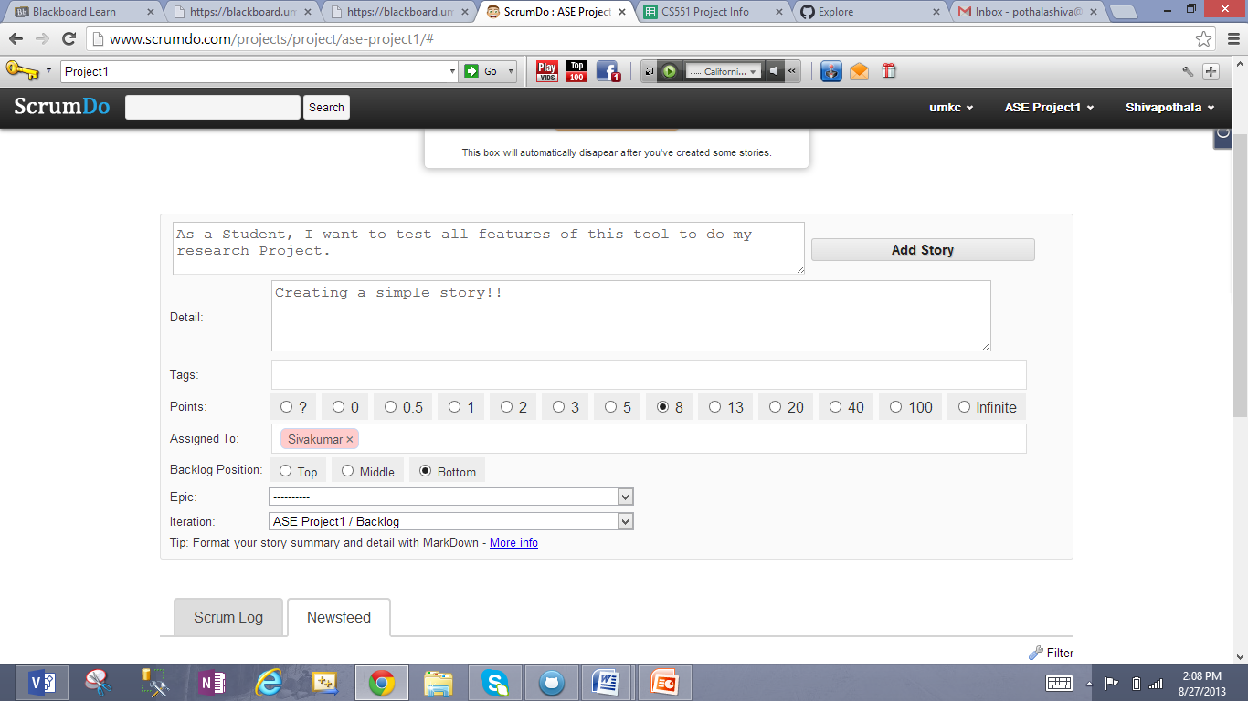

1. Creating another story to install Eclipse

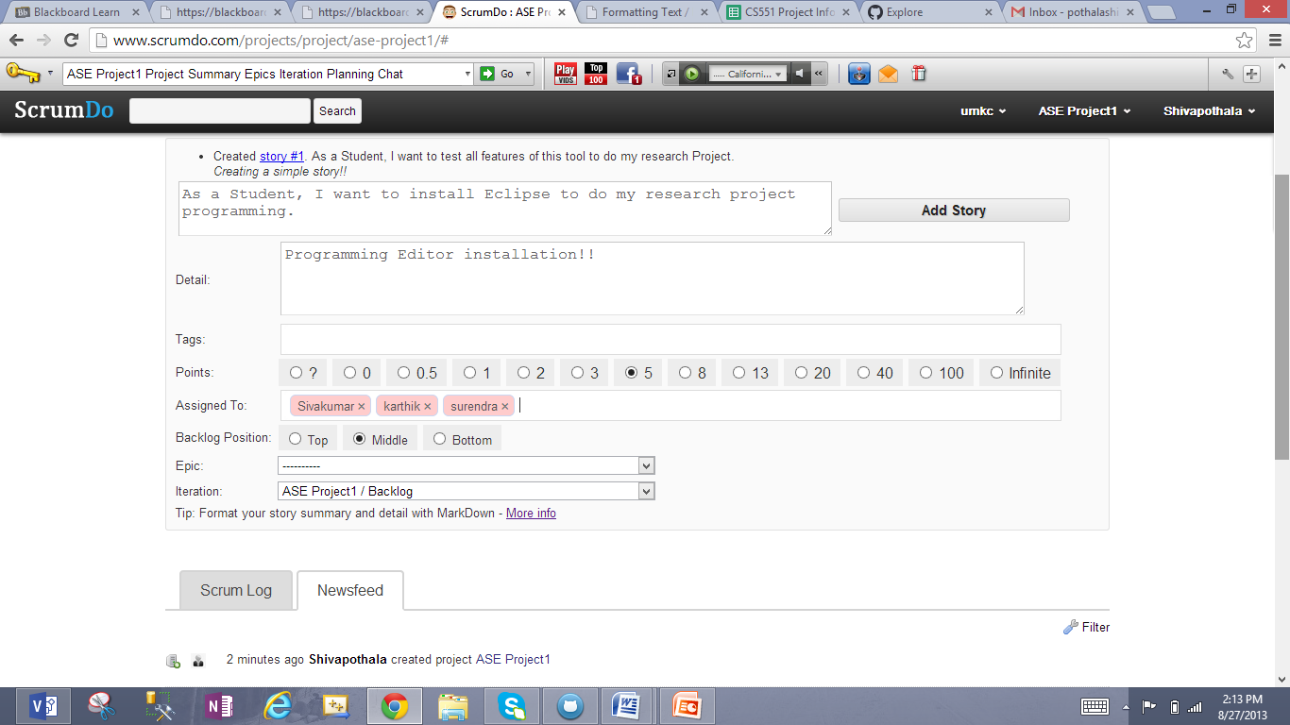

1. Updating First story by adding Category "Testing" and Status "Doing"

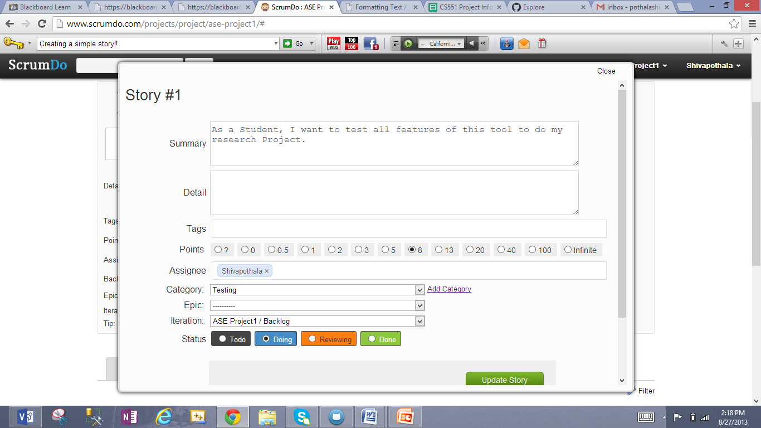

1. Updating Second story by adding category "Installation" and status "Todo"

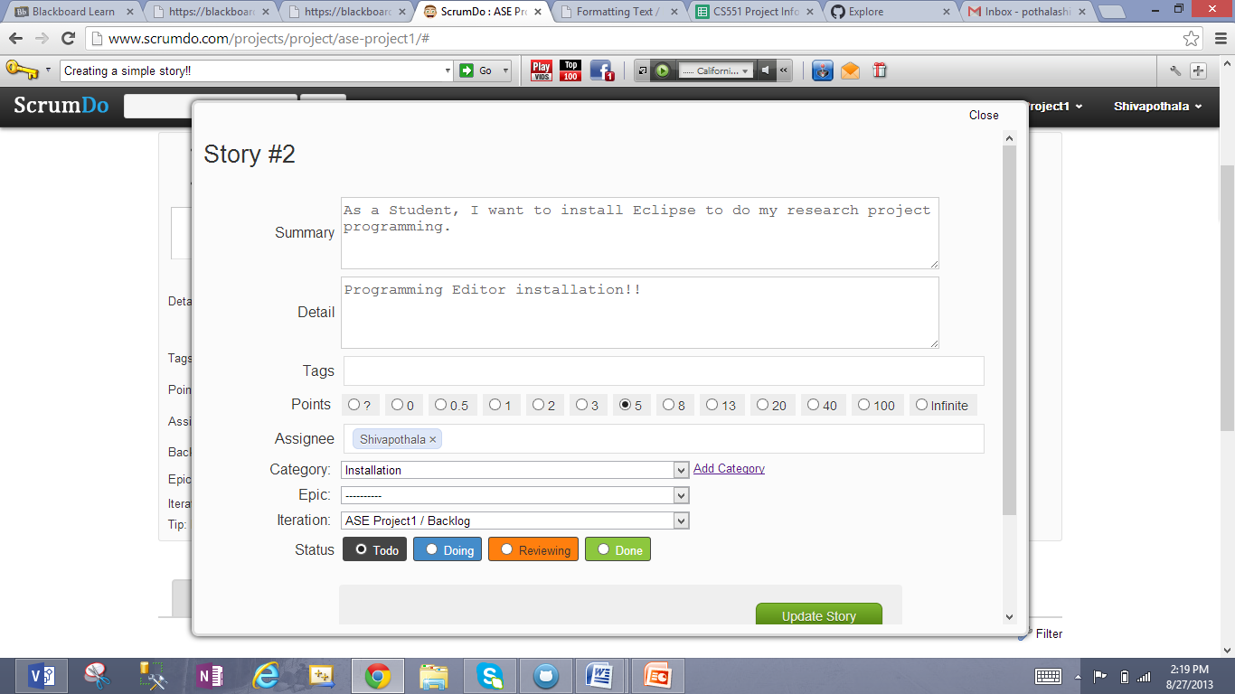

1. See Backlog stories created, Assigned persons and hours to work on them.

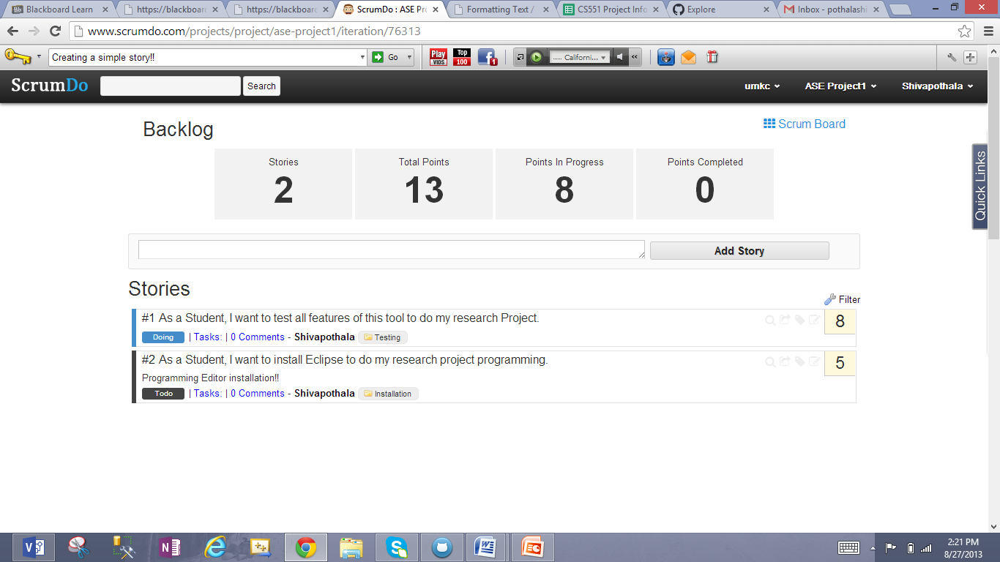

1. Added one more story and now you can see different status for each story

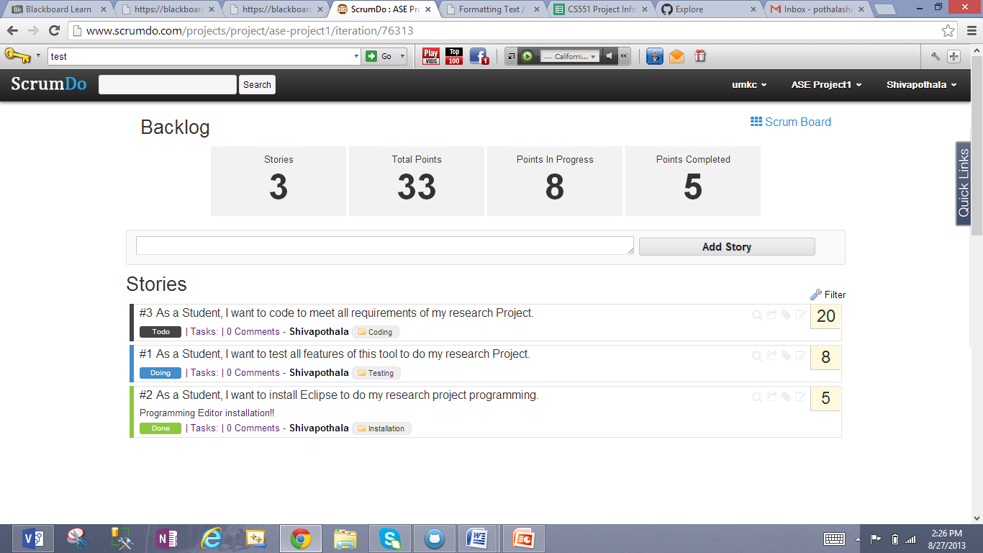

1. Created New Iterations "Iteration#1" and "Iteration#2"

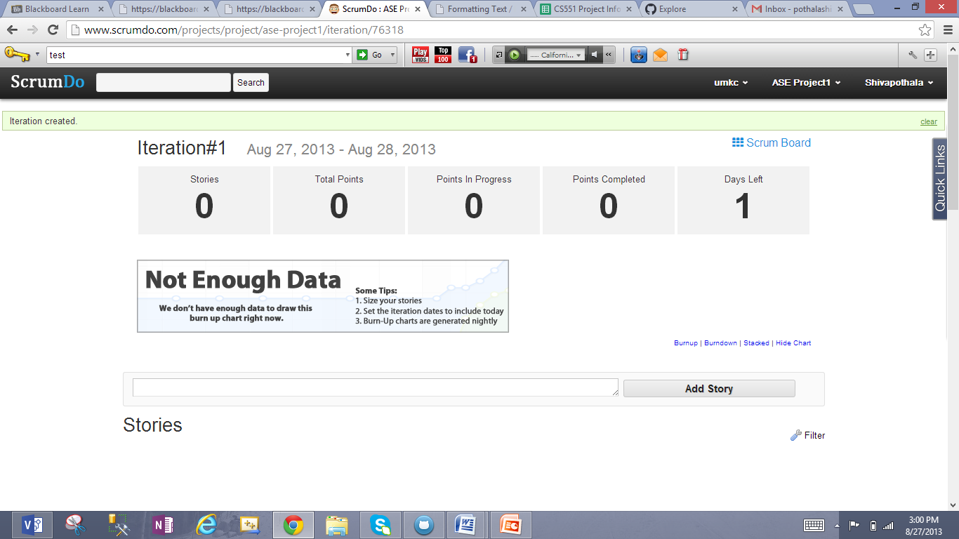

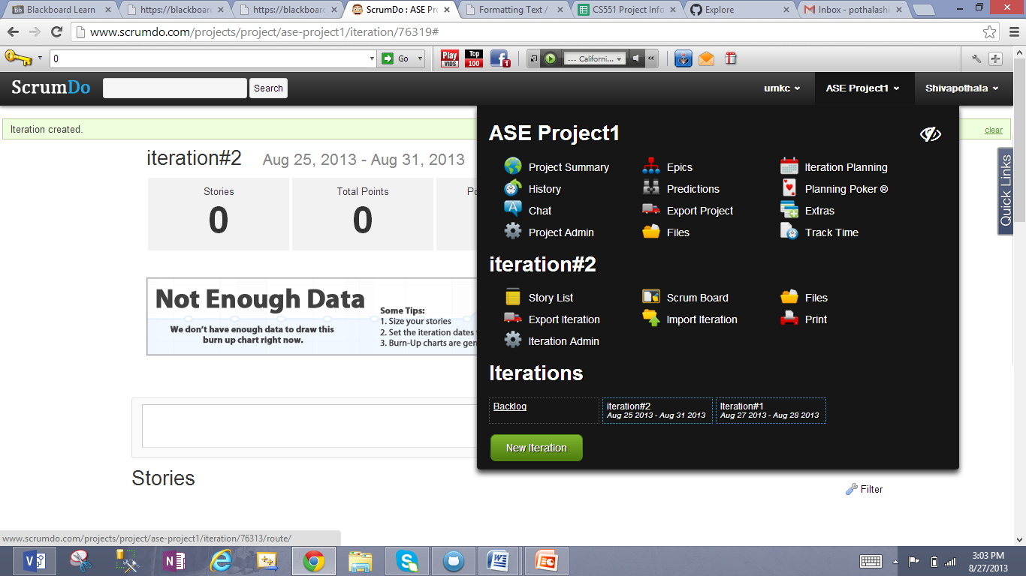

1. Iteration Planning after creating two iteration for different tasks see story#5 in the first screen and story#4 in the second screen.

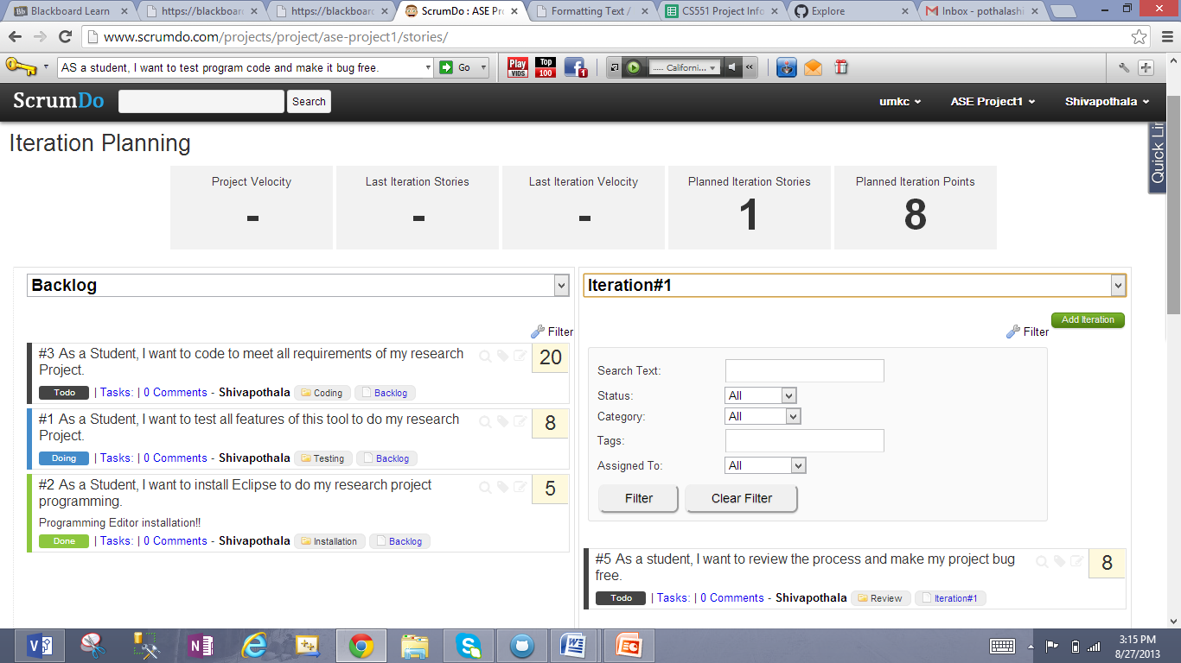

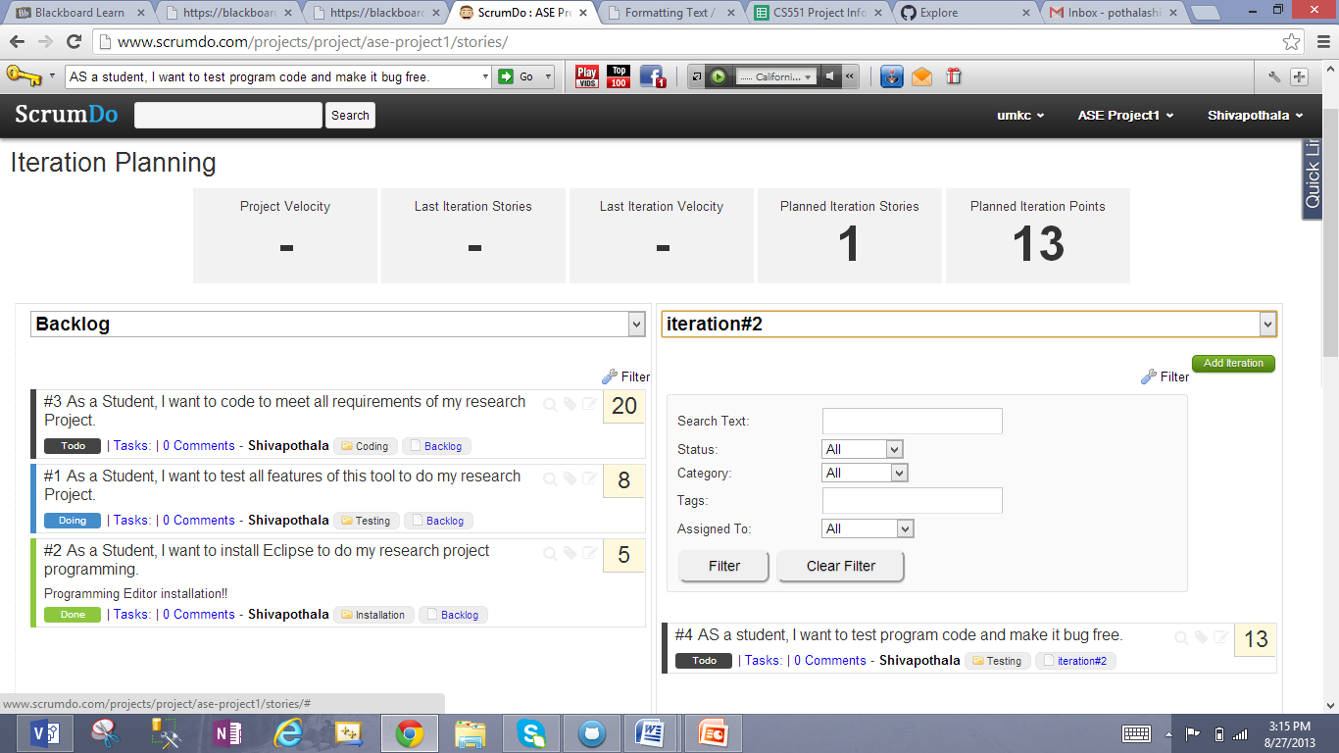

1. Created Epic Story to develop a "Web application"

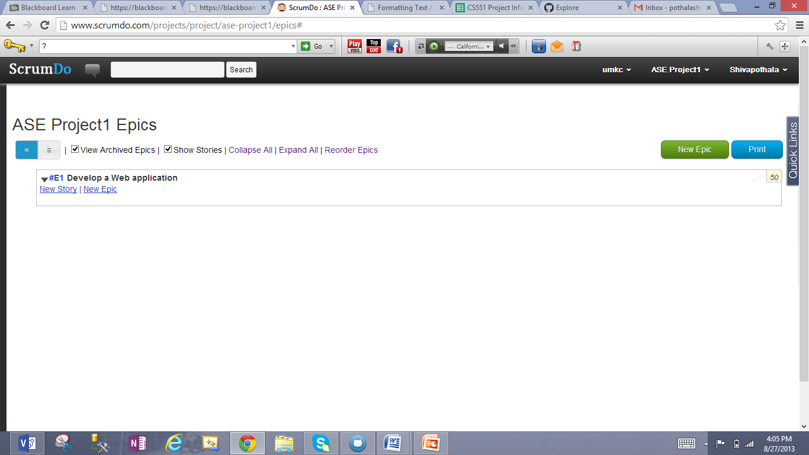

1. Created two sub epic stories for "WebGUI" and "Data Load" to complete Epic story

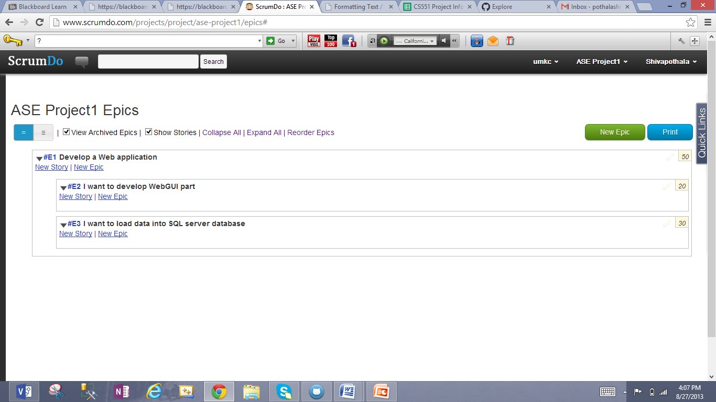

1. See "**Burnup**" charts for Iteration#2 and Iteration#1

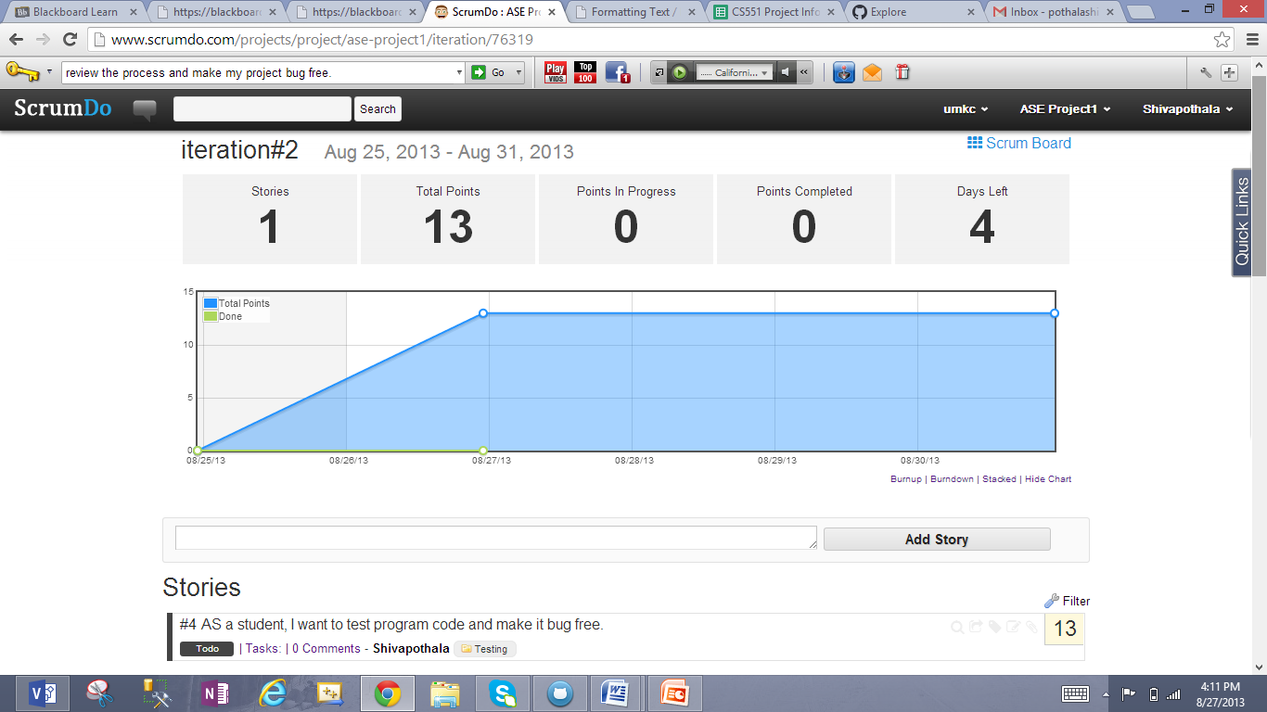

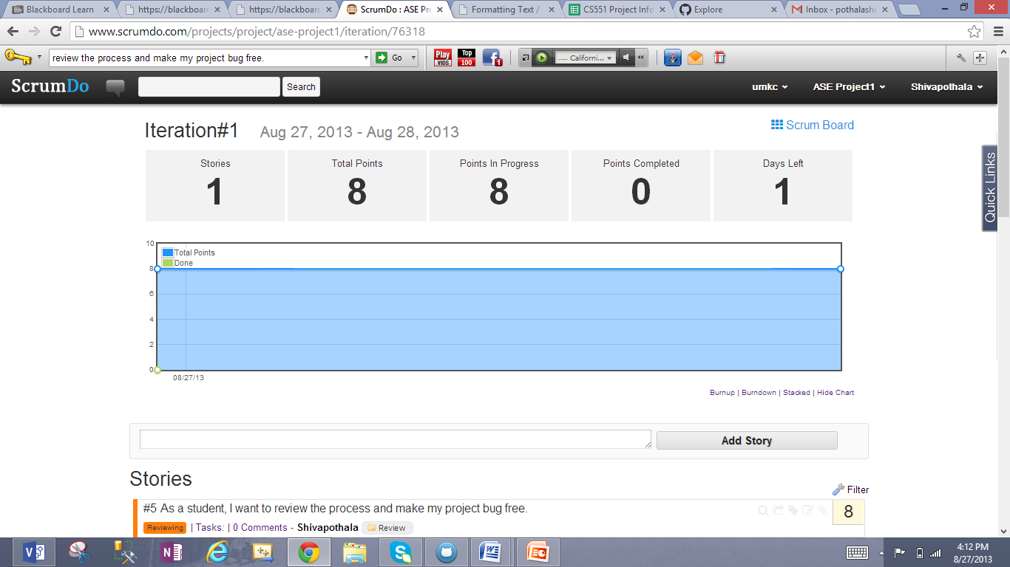

1. See "**Burndown**" charts for Iteration#2 and Iteration#1

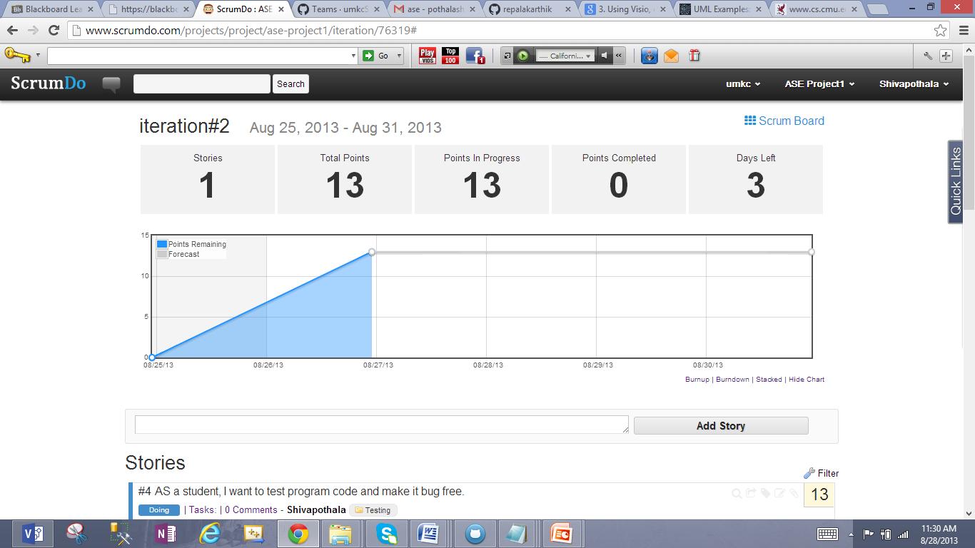

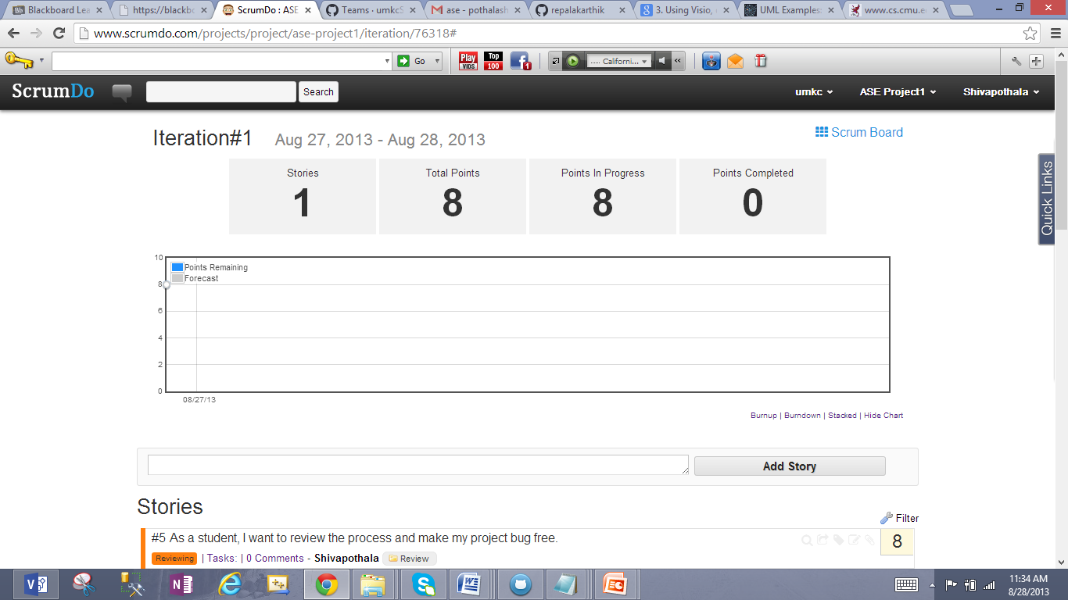

1. "**Scrum Board**" to view status of all tasks assigned

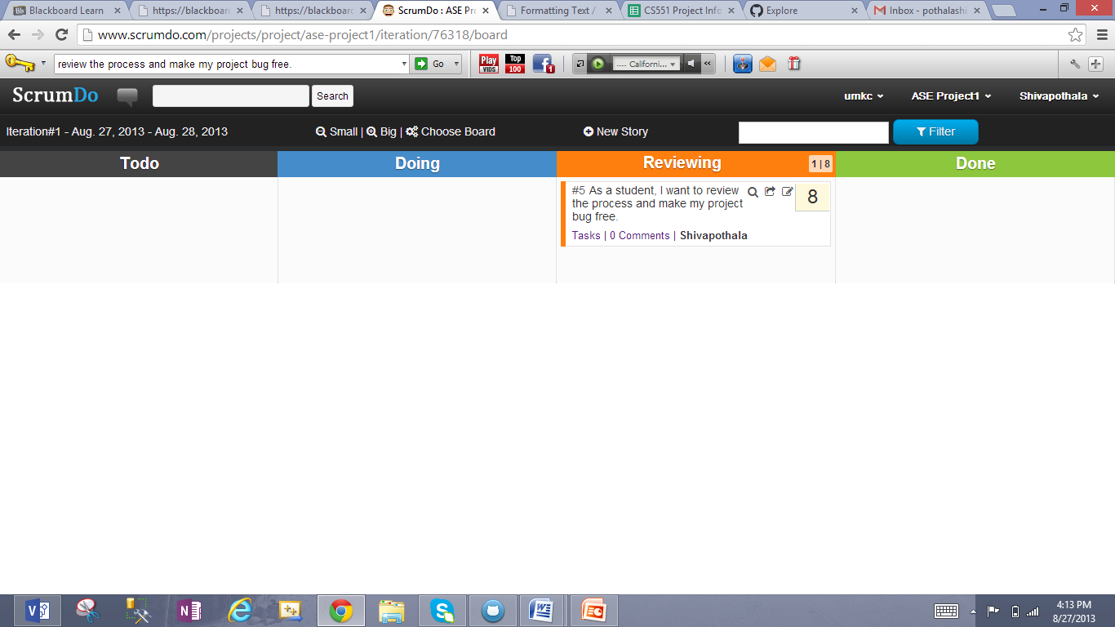

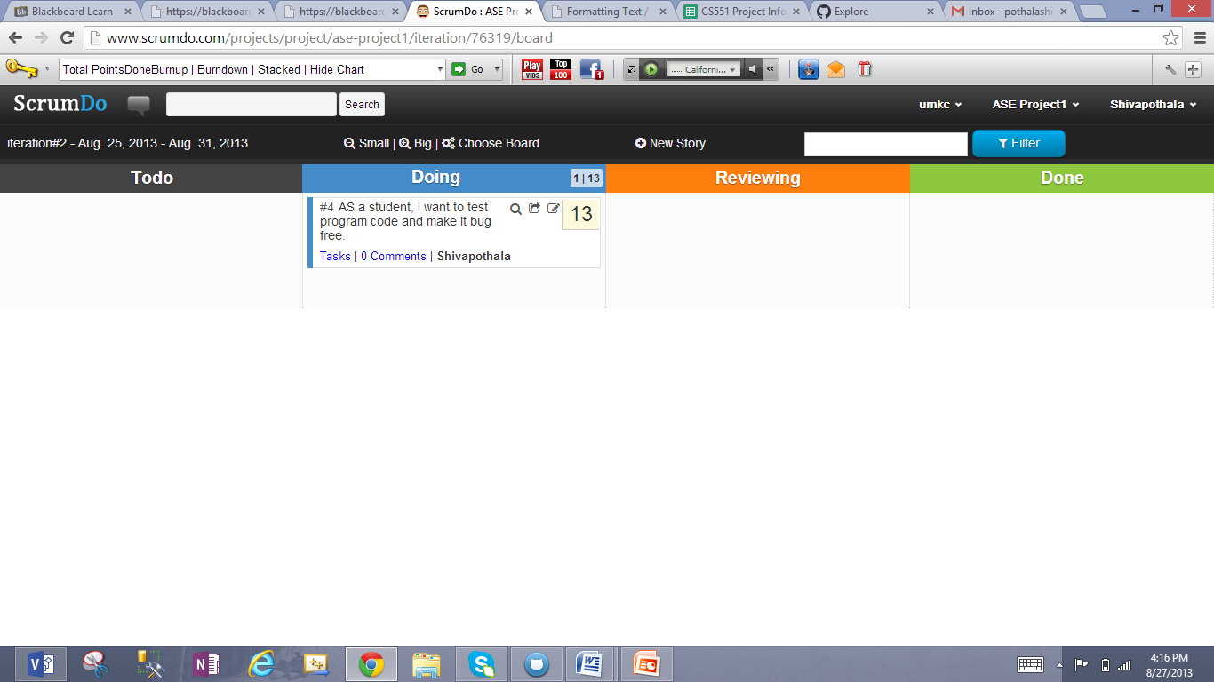

1. Created new Team and invited my temmates "Kathik Repala" and "Surendra Koripella", also gave write access to team members for ASE Project1.

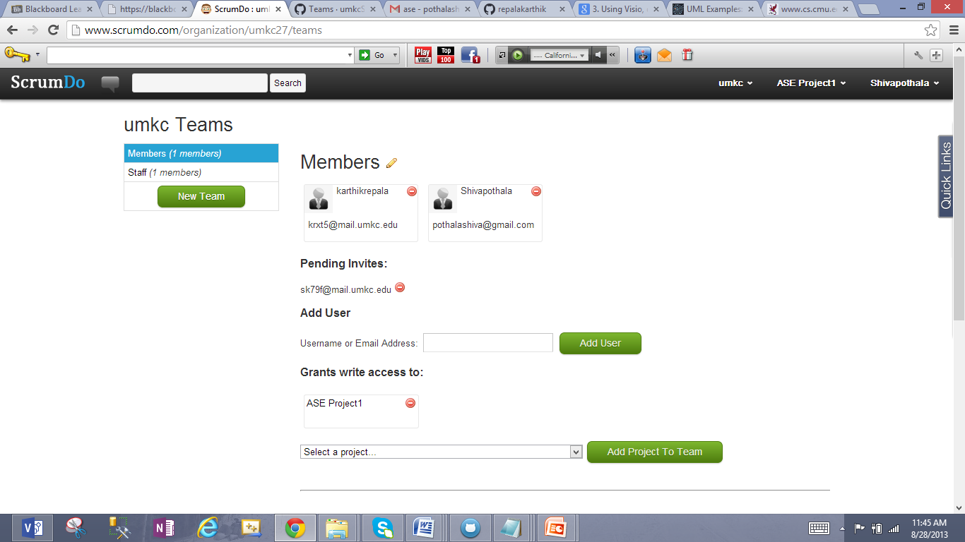

1. View of umkc Dashboard

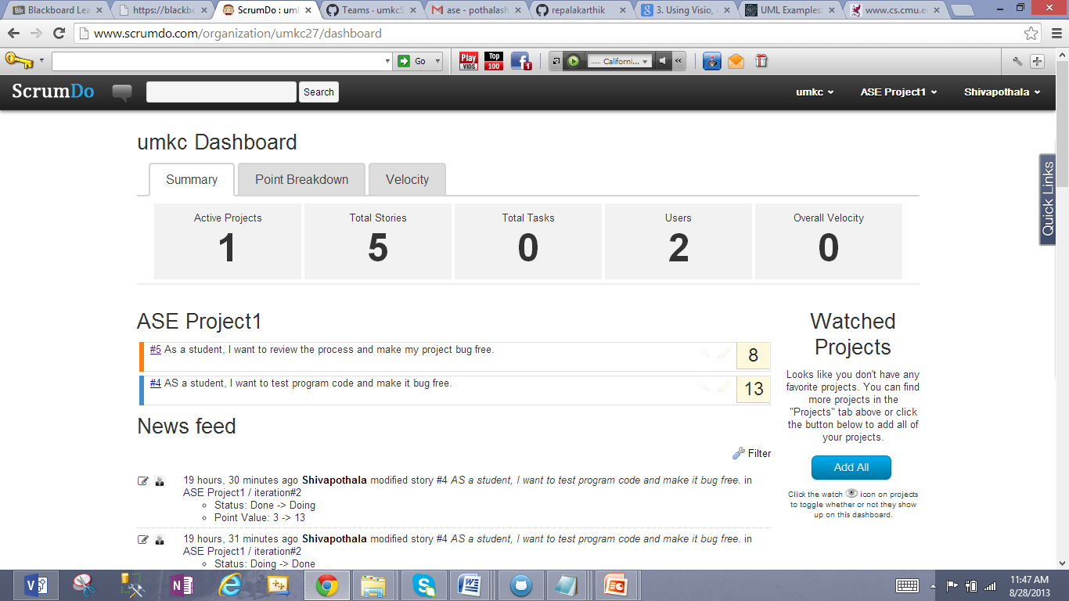

***********************************done ScrumDo************************************

# Git Hub

1. Created and logged into new Git hub account "shivapothala"

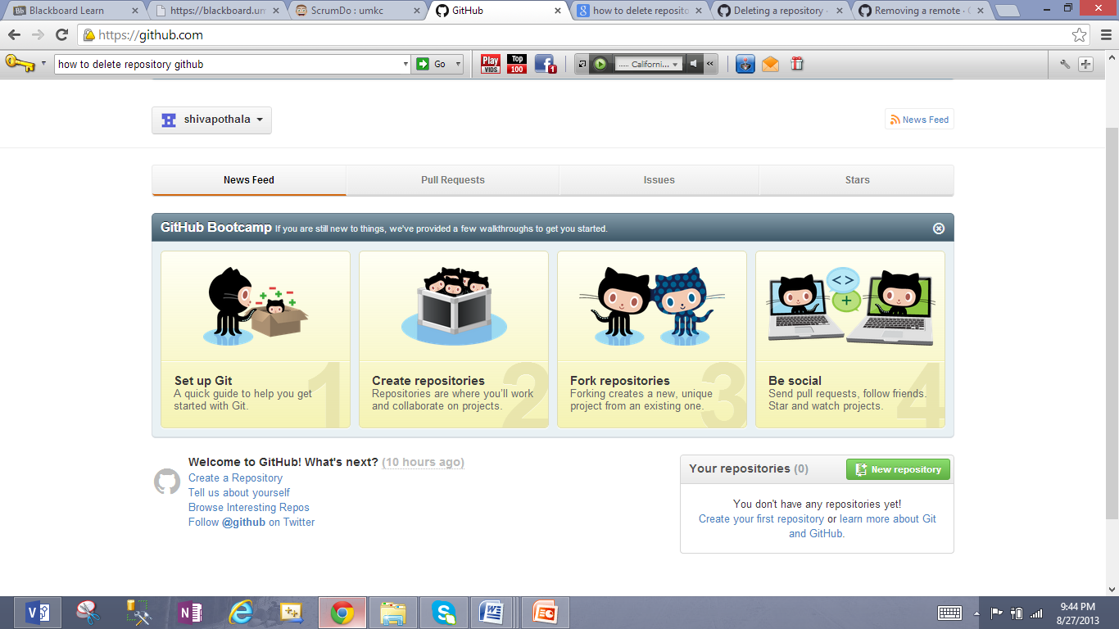

1. Created a new Repository "Project1"

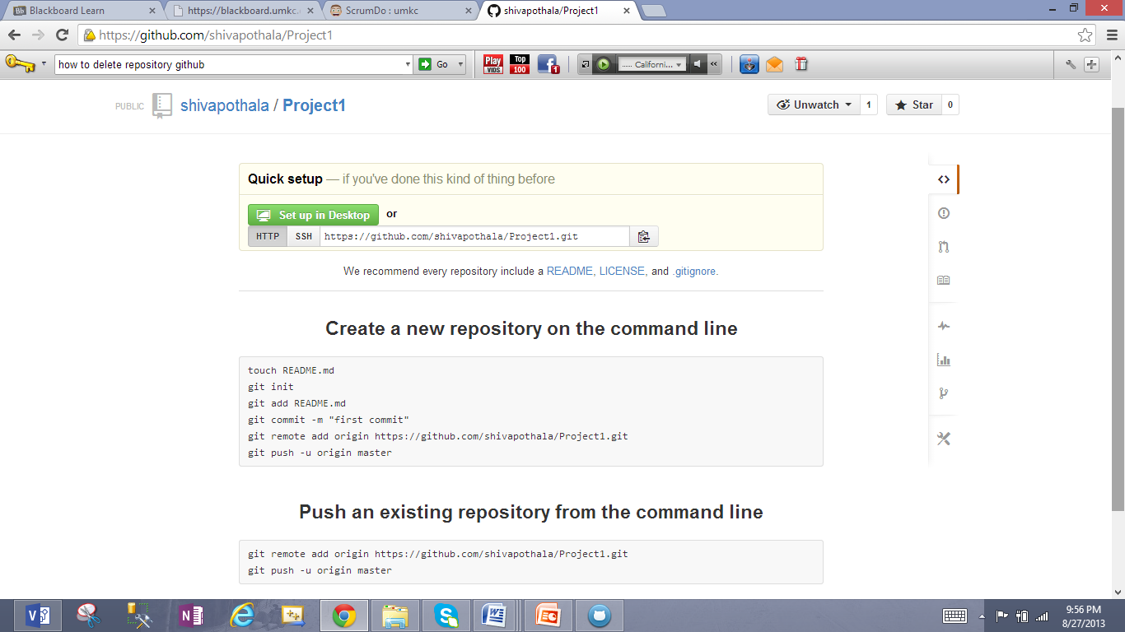

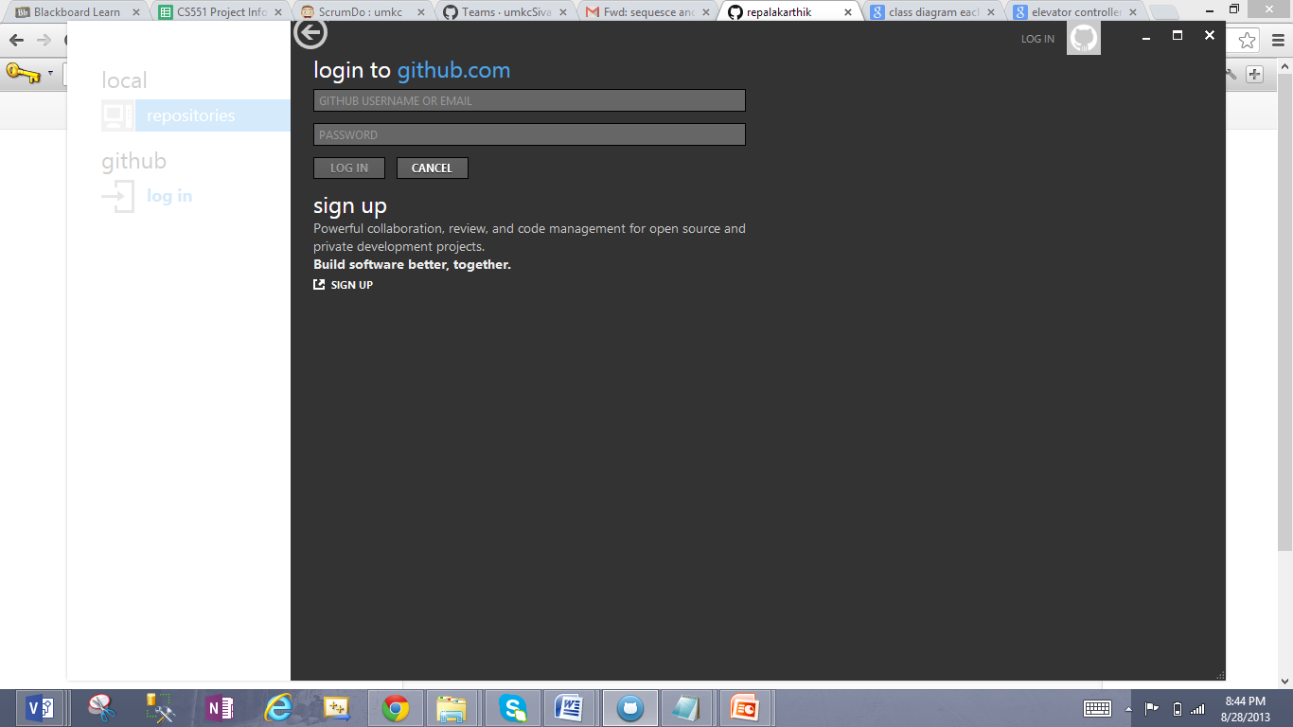

1. Logged into github account shivapothala and it shows no repositories present "**Before Clone"**

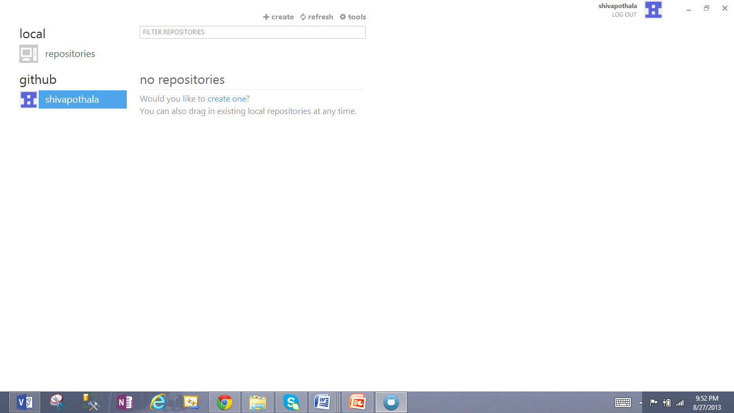

1. After Clone, we can see Project1 in github repositories

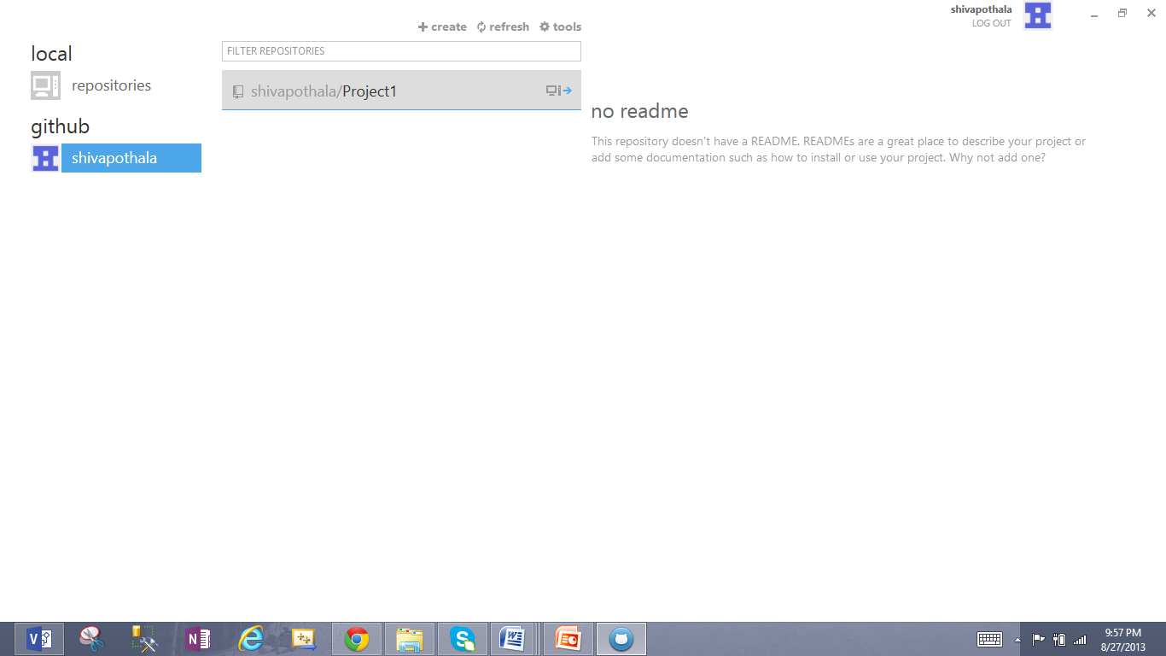

1. Adding text file"Sampl1.txt" in local repository **C:\Users\shiva\Documents\GitHub\Project1**

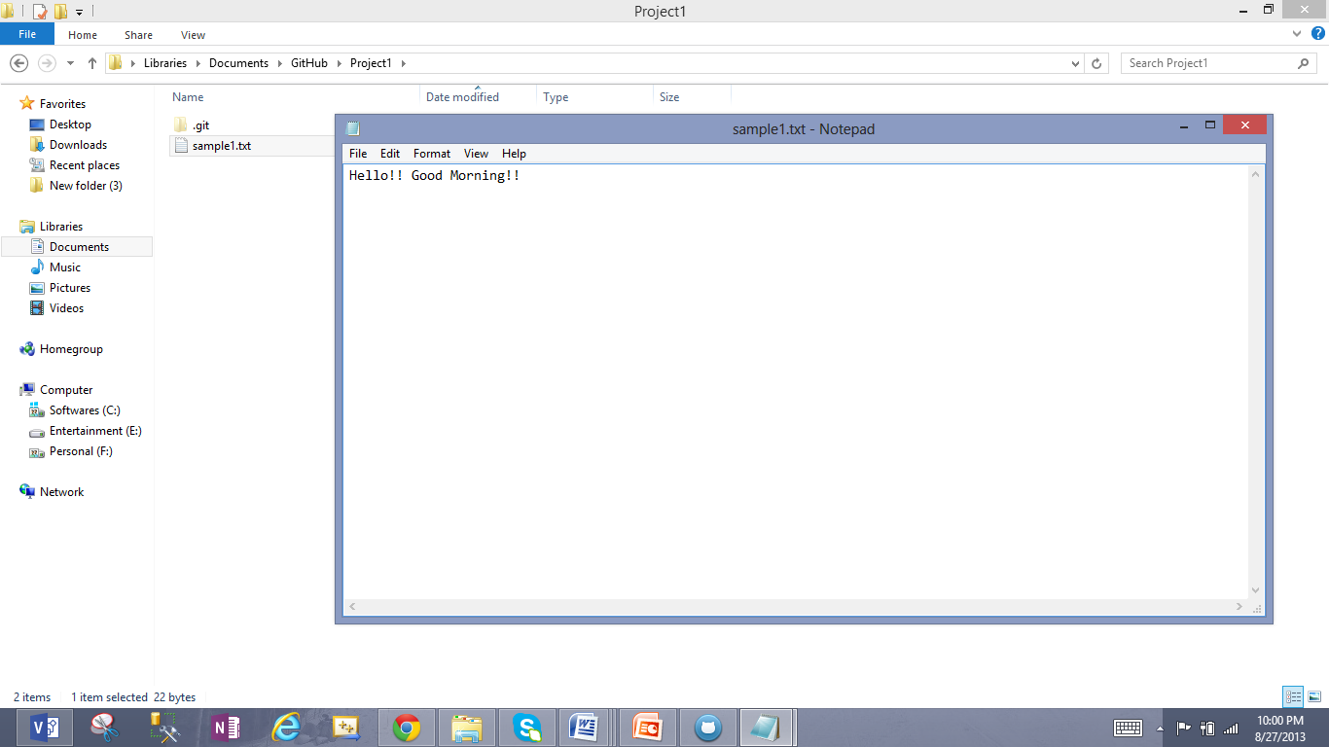

1. Making Initial commit for synchronization

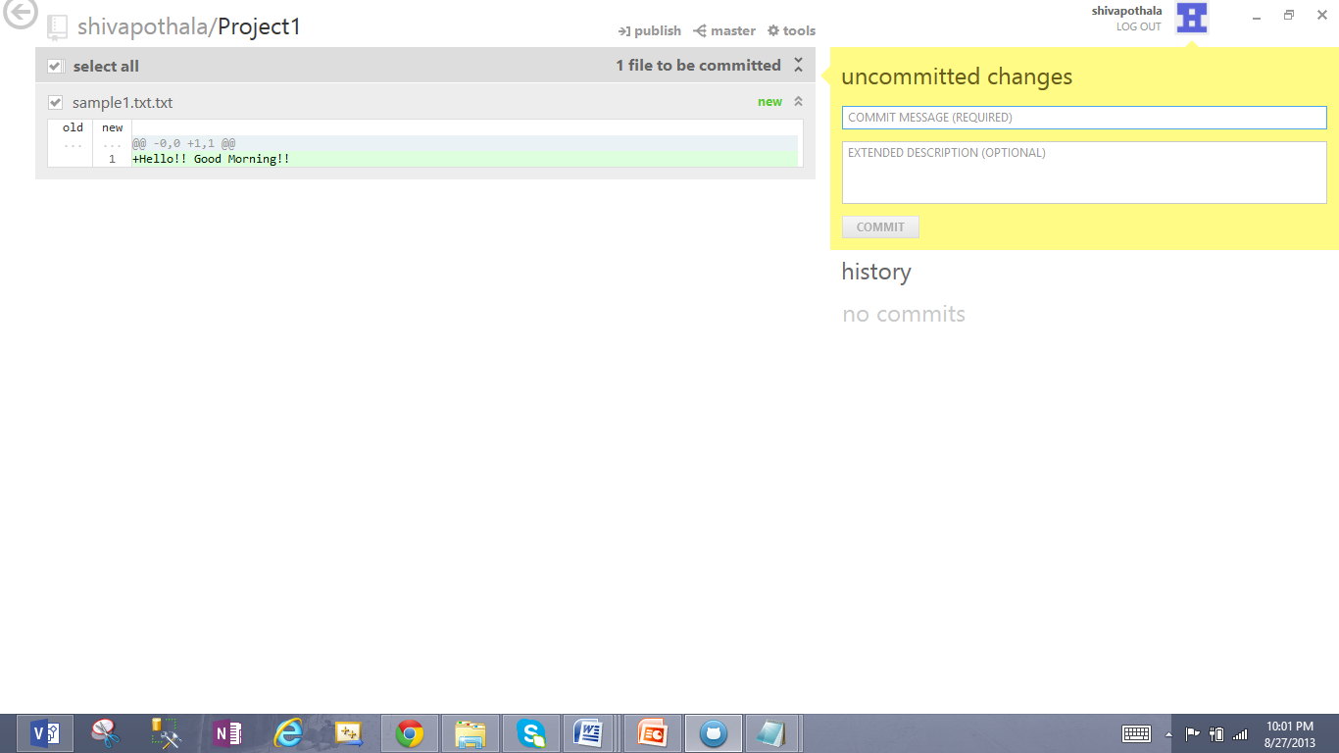

1. After commit it says "no uncommitted changes" and First commit by Sivakumar

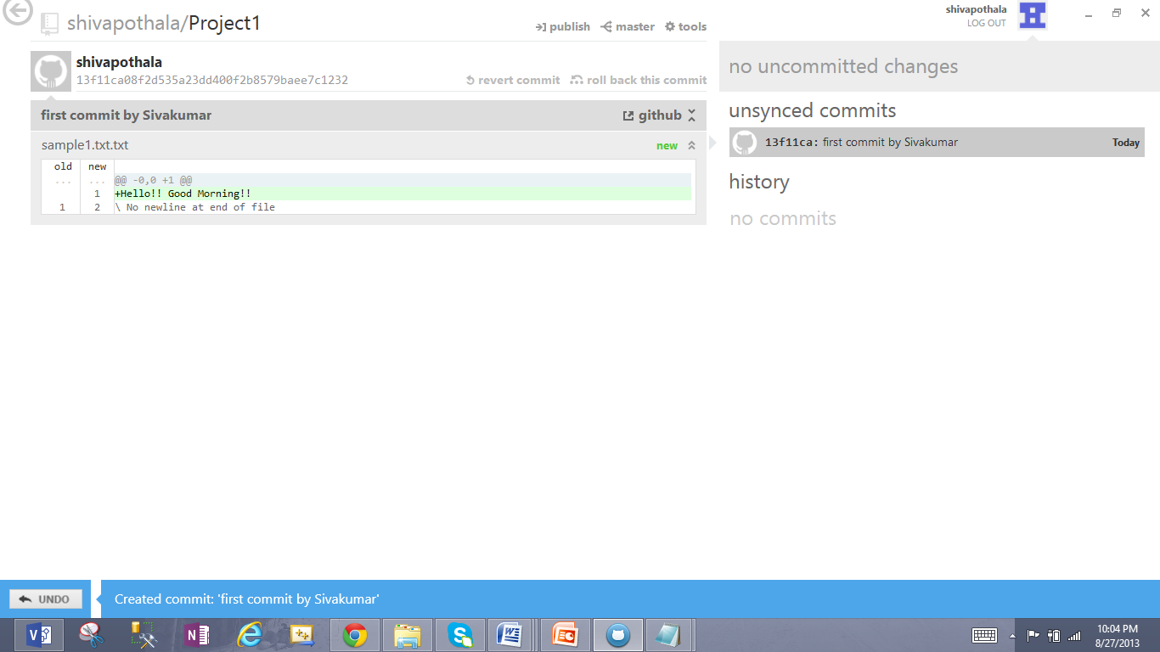

1. Publishing the file for syncing with the local file

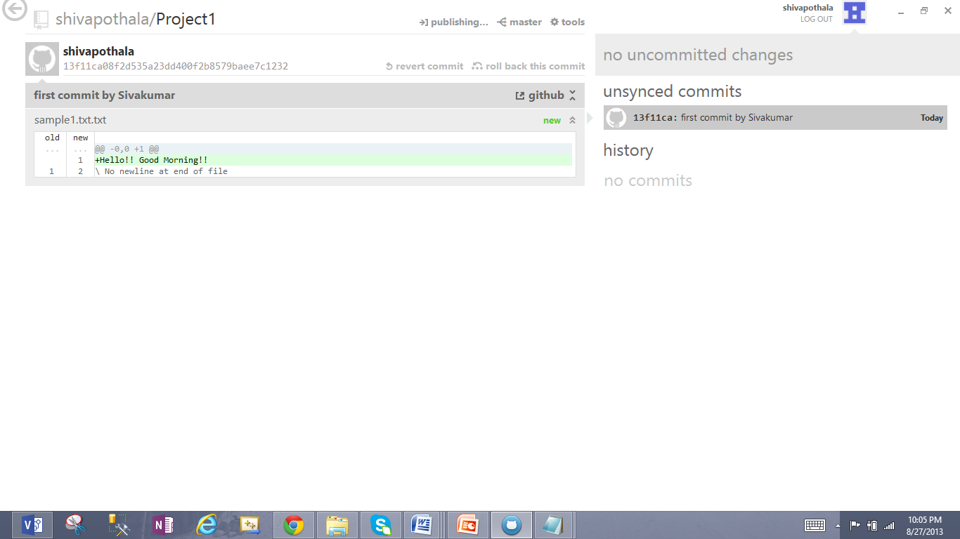

1. See" in sync" status for the published file

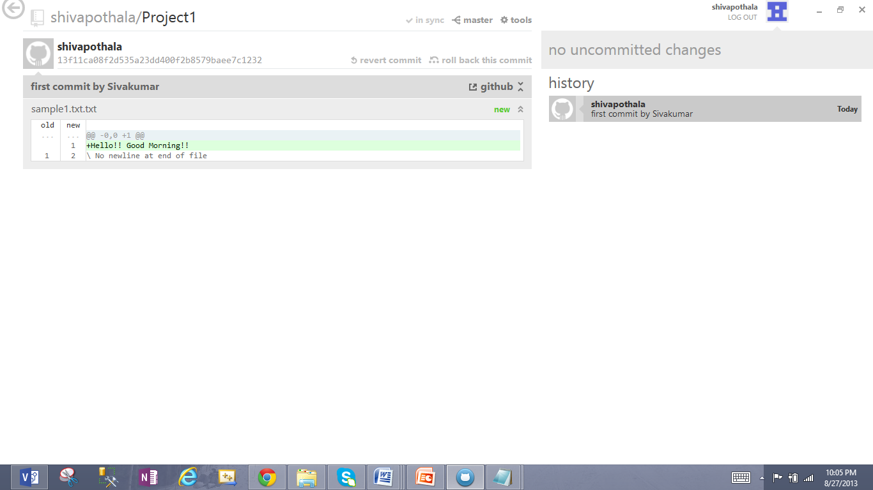

1. Checking sync in remote

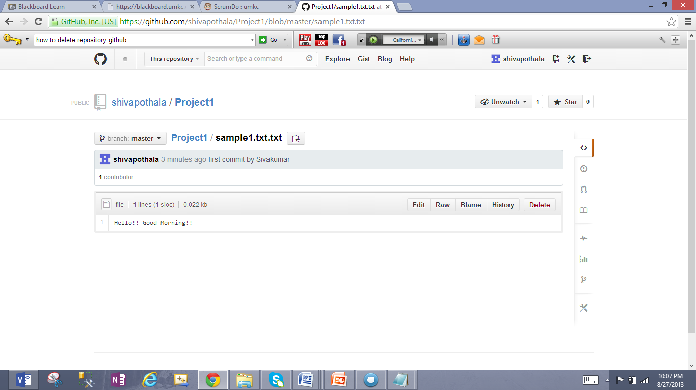

1. Created new Organization account "umkcpothala"

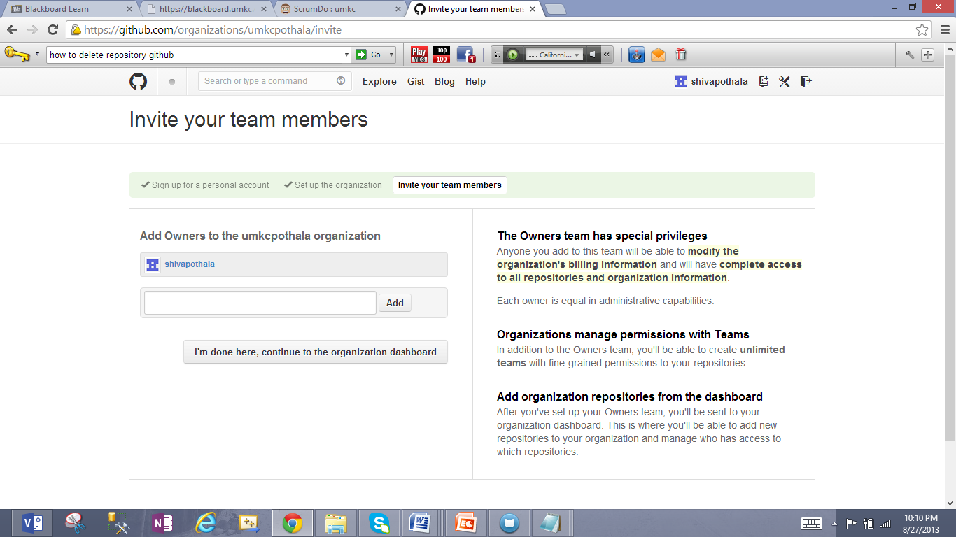

1. Added owner to the organization.

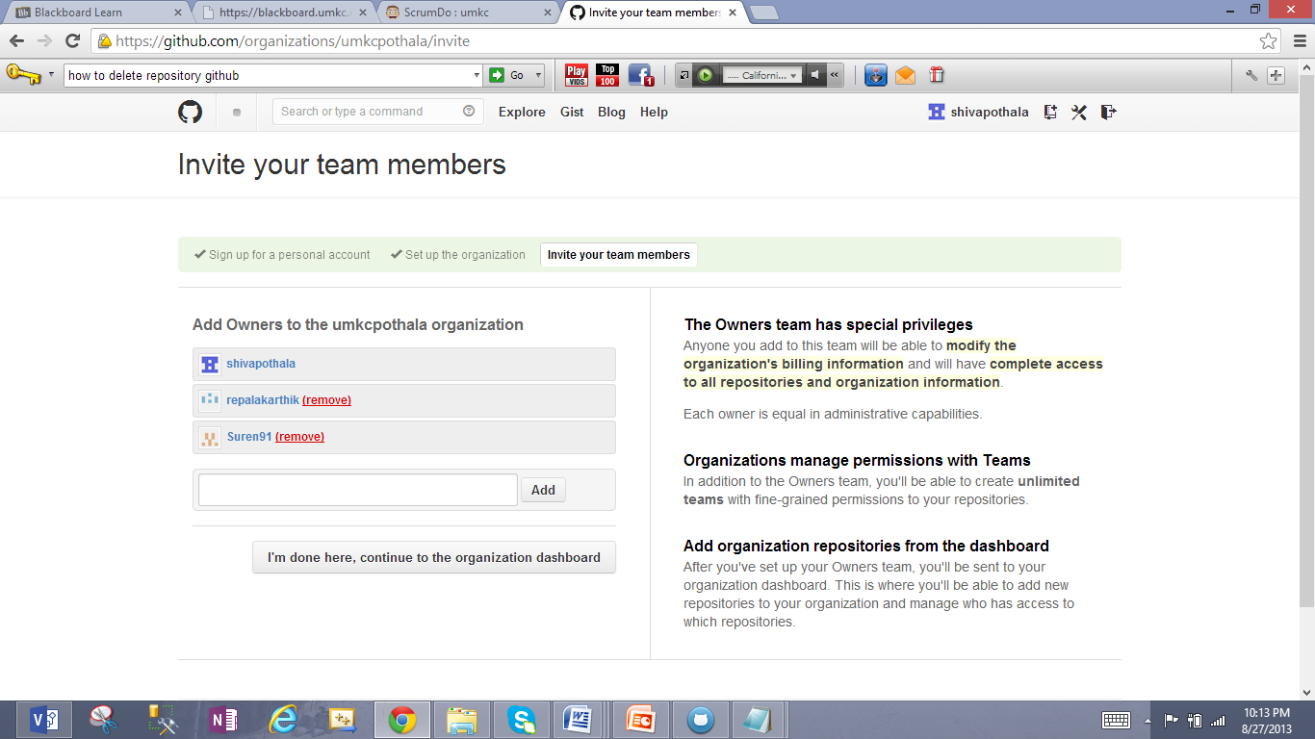

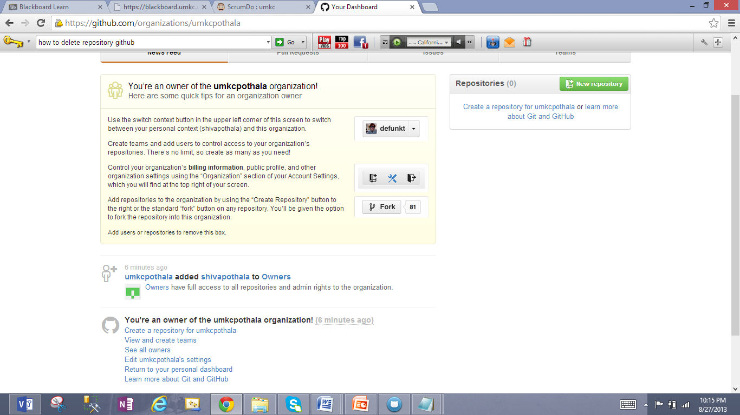

1. Added a team "ASE team", team members and repository "ASEProject1" and granted Push & Pull access

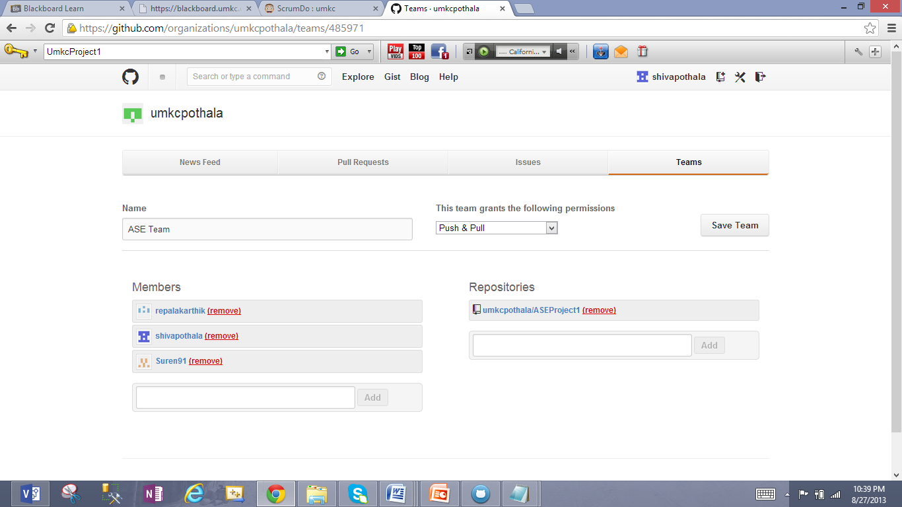

1. checking News feed for the organization

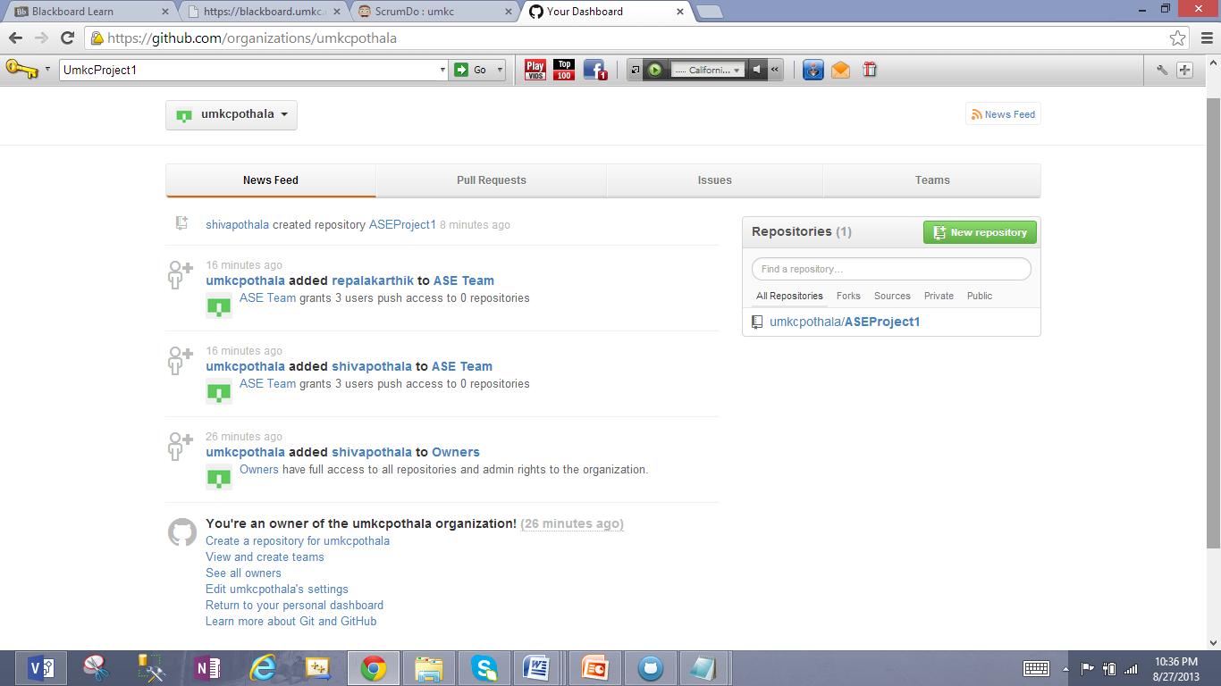

1. Logged in as other team member **"reapalakarthik"** and see ASEProject1 **"After Cloning"**

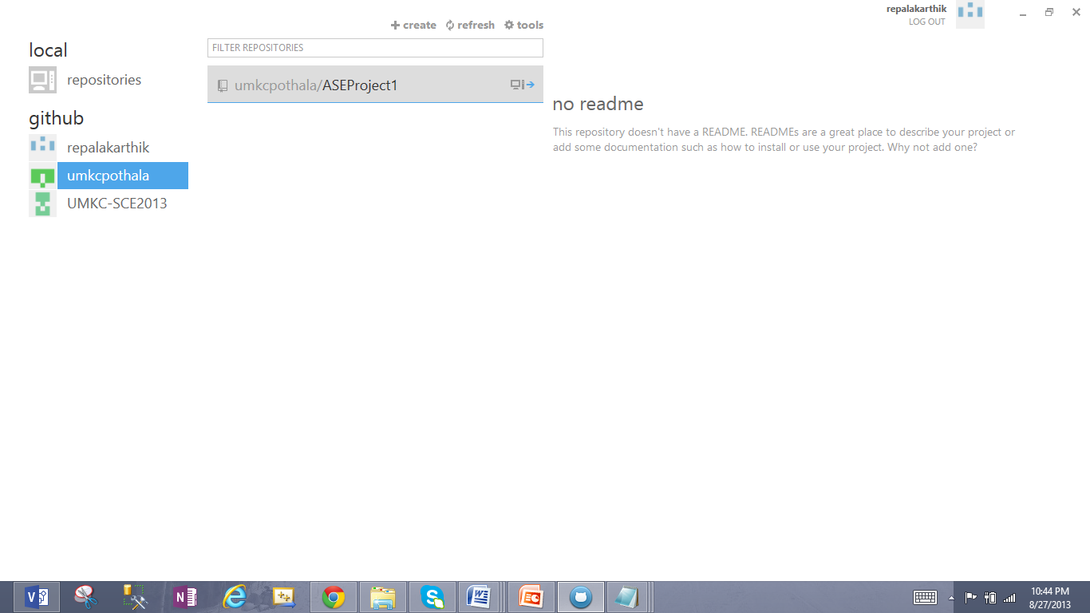

1. Making changes to the file Sample2.txt

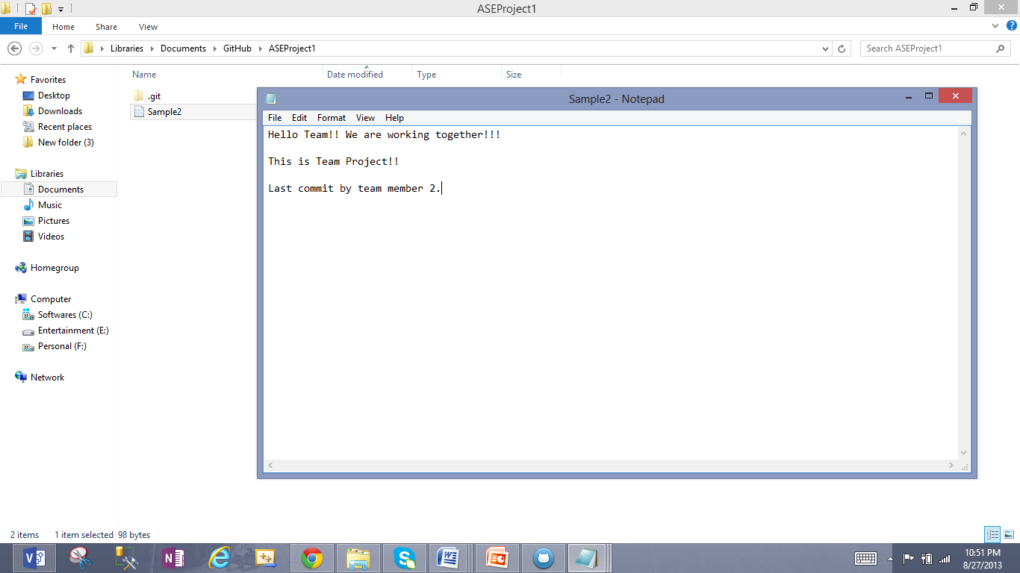

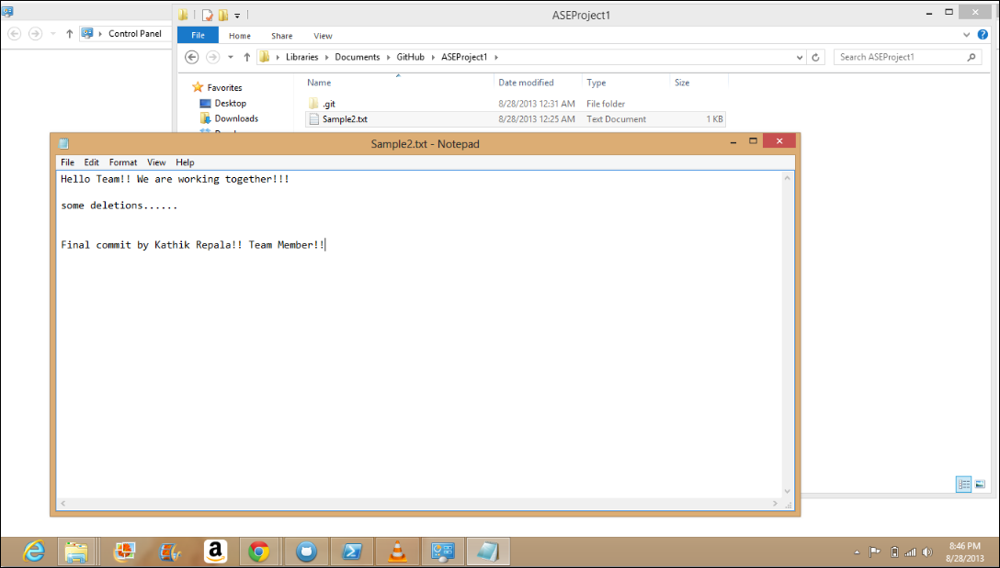

1. Final commit by karthik repala for new changes

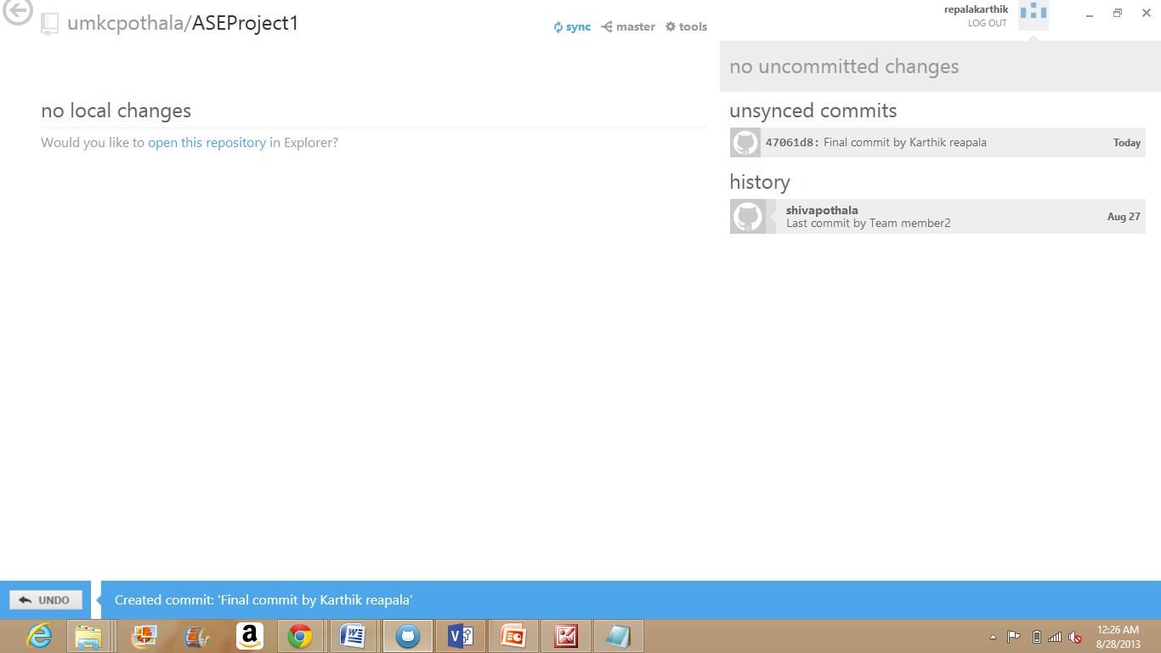

1. See committed changes

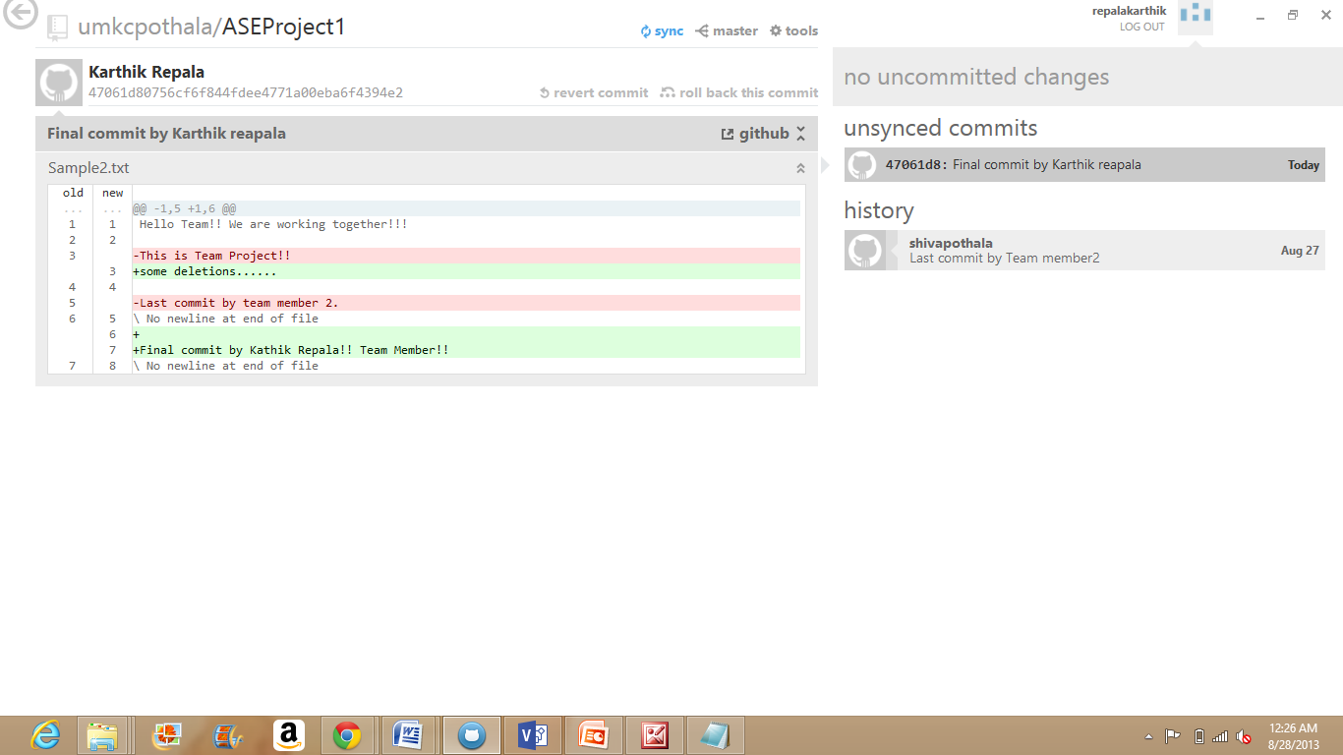

1. Syncing all committed changes

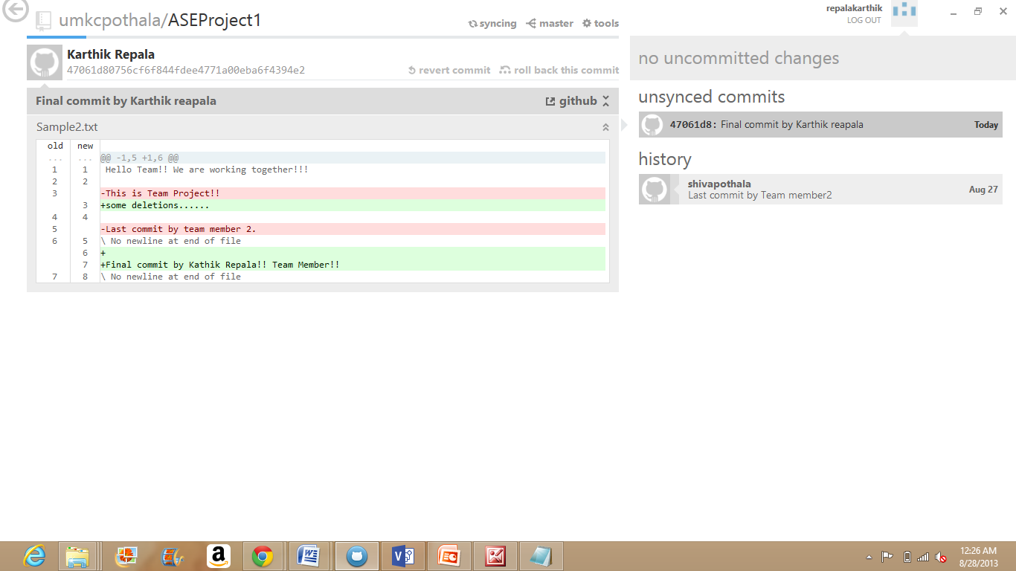

1. After Sync, We can see "in sync" status

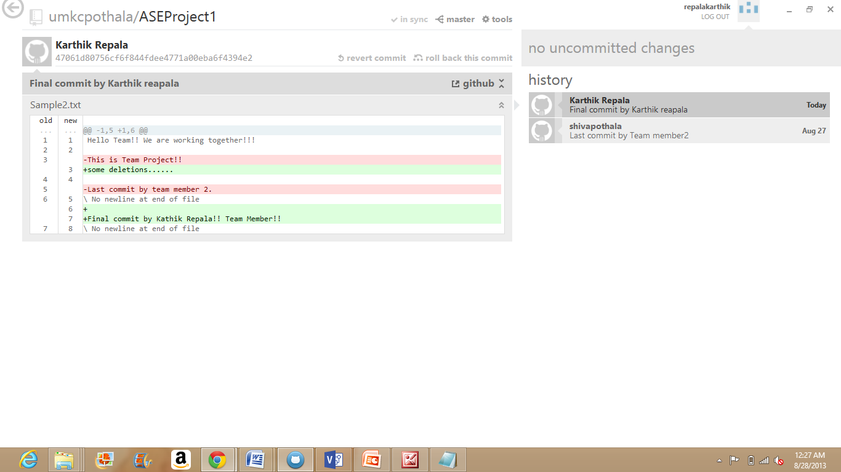

*******************************Done Git Hub*****************************************

1. Using Visio, draw the Class diagram for the elevator system

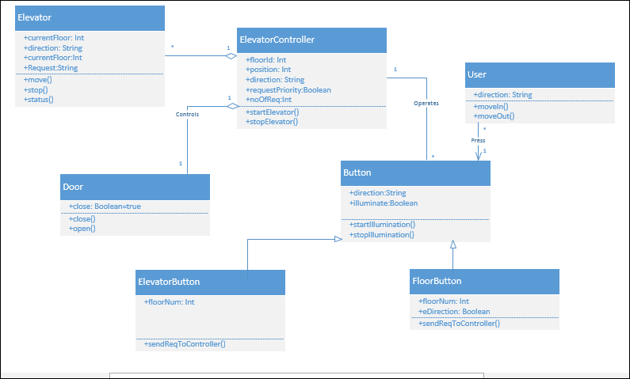

Class Diagram

1. Using Visio, draw the Sequence diagram pertaining to the floor button

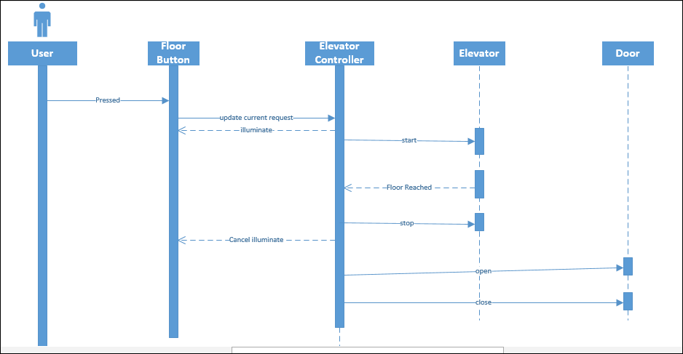

Sequence Diagram

1. Using Visio, draw the Architecture diagram for the elevator management system

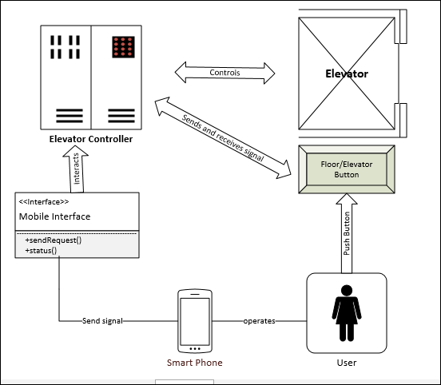

Architecture Diagram

**You can also view these diagrams by clicking below images**

**  **